Imperative Sentences

✅ Definition:
# Source: Chatgpt (GPT-4-turbo) at [7/28/2025]
An imperative sentence gives a command, instruction, request, advice, or warning.
It tells someone what to do, either directly or politely.

🧩 Key Features of Imperative Sentences:
# Source: Chatgpt (GPT-4-turbo) at [7/28/2025]
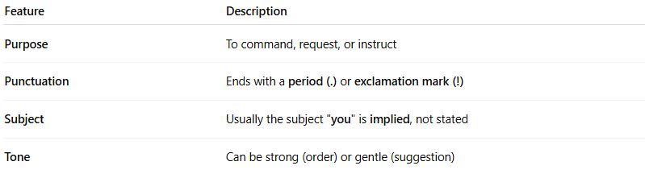
Feature | Description
Purpose | To command, request, or instruct
Punctuation | Ends with a period (.) or exclamation mark (!)
Subject | Usually the subject "you" is implied, not stated
Tone | Can be strong (order) or gentle (suggestion)

✏️ Examples of Imperative Sentences:
# Source: Chatgpt (GPT-4-turbo) at [7/28/2025]
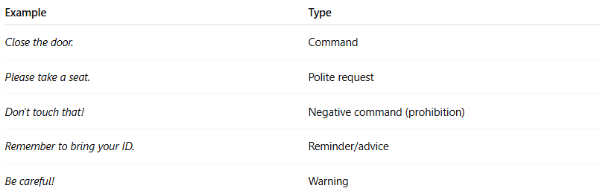
Example | Type
Close the door. | Command
Please take a seat. | Polite request
Don't touch that! | Negative command (prohibition)
Remember to bring your ID. | Reminder/advice
Be careful! | Warning

🔧 Structure of Imperative Sentences:
# Source: Chatgpt (GPT-4-turbo) at [7/28/2025]
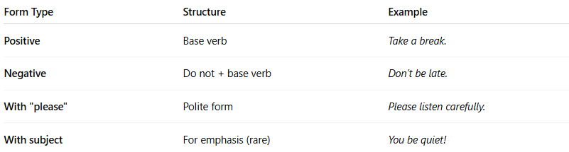
Form Type | Structure | Example
Positive | Base verb | Take a break.
Negative | Do not + base verb | Don’t be late.
With "please" | Polite form | Please listen carefully.
With subject | For emphasis (rare) | You be quiet!

📌 Common Uses of Imperatives:
# Source: Chatgpt (GPT-4-turbo) at [7/28/2025]
- Instructions: Turn left at the traffic light.
- Advice: Get enough sleep.
- Requests: Pass the salt, please.
- Warnings: Watch out!
- Invitations: Come in.
- Rules/Notices: Do not enter.

🔍 Imperative Sentence vs. Other Types
# Source: Chatgpt (GPT-4-turbo) at [7/28/2025]
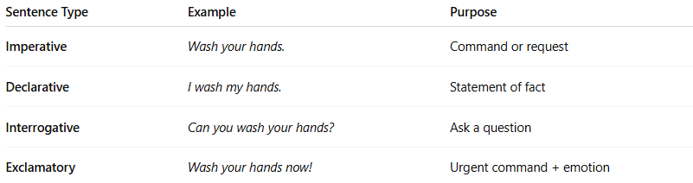
Sentence Type | Example | Purpose
Imperative | Wash your hands. | Command or request
Declarative | I wash my hands. | Statement of fact
Interrogative | Can you wash your hands? | Ask a question
Exclamatory | Wash your hands now! | Urgent command + emotion

🧠 Summary:
# Source: Chatgpt (GPT-4-turbo) at [7/28/2025]
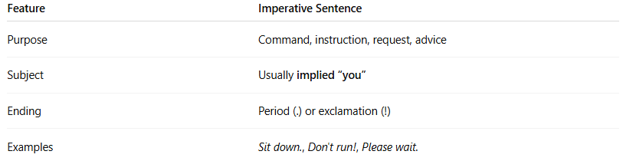
Feature | Imperative Sentence
Purpose | Command, instruction, request, advice
Subject | Usually implied “you”
Ending | Period (.) or exclamation (!)
Examples | Sit down., Don't run!, Please wait.

